**Off-the-Job Summary Statement**

At the end of apprentice’s programme, if the volume of off-the-job training hours delivered is less than the original volume of planned hours, the ESFA formally require that a statement to summarise the activity which has been undertaken is produced and in the following format:

|  |  |
| --- | --- |
|  |  |
| Apprentice Name |  |
| Employer Name |  |
| Training Provider |  |
| Contracted Working Hours |  |
| Programme |  |
|  |  |
| Apprenticeship Start Date |  |
| Planned Apprenticeship End Date |  |
| Actual Apprenticeship End Date |  |
| How many months has the apprentice been on programme for |  |
| Has the apprentice been on programme longer than the 12 month minimum duration? |  |
|  |  |
| Original volume of planned off-the-job hours planned at the start |  |
| Volume of actual off-the-job hours delivered * |  |
| Variance in Planned vs Actual off-the-job hours |  |
| Has the apprentice undertaken at least 20% of the their working time over the actual time on programme. |  |
| The reason(s) for this difference | Xxxx completed the full content of the apprenticeship over a shorter timescale than originally expected |

*The actual hours delivered, supported by proof of delivery retained by the training provider in the evidence pack and correlates with the number of hours recorded in the actual hours’ field of the Individual Learner Record (ILR).

In counter-signing this statement you agree with the information as recorded above is correct and you are satisfied with the quantity of off-the-job training that was delivered by the training provider, even though this is different to the original volume agreed at the beginning of the apprenticeship.

On Behalf of the Employer

Print Name, Job Title and Date: Operations Director 05/08/2020

Apprentice:

Print Name and Date 05/08/2020

**Apprenticeship Programme - Record of Partial Completion**

**Apprentice Name:**

**Apprenticeship Programme**

**Apprenticeship Starts Date**

**Apprenticeship Planned End Date**

**Actual Apprenticeship Withdrawal Date**

xxxx was undertaking a two-year, level 3 xxxx apprenticeship, which he was enrolled on in January 2020. When xxxx was made redundant he was 8 months into his apprenticeship, around 33% of the way through his apprenticeship. A summary of learning activity is as follows:

|  |  |  |
| --- | --- | --- |
| **Knowledge Modules / Vendor / Professional Qualification Summary** | | |
| Knowledge Module:  Principles of Coding | City & Guilds | Completed  Passed March 2020 |
| Knowledge Module:  Marketing Principles | City & Guilds | Completed  Passed June 2020 |
| Vendor Qualification:  Data Analytics | CIW | Started July 2020 |

|  |  |  |
| --- | --- | --- |
| **Maths & English Attainment** | | |
| Functional Skills  Maths Level 2 | City & Guilds | Completed  Passed May 2020 |
| Functional Skills  English L2 | City & Guilds | Completed  Passed June 2020 |

**Knowledge Skills, Behaviours (KSBs) Summary**

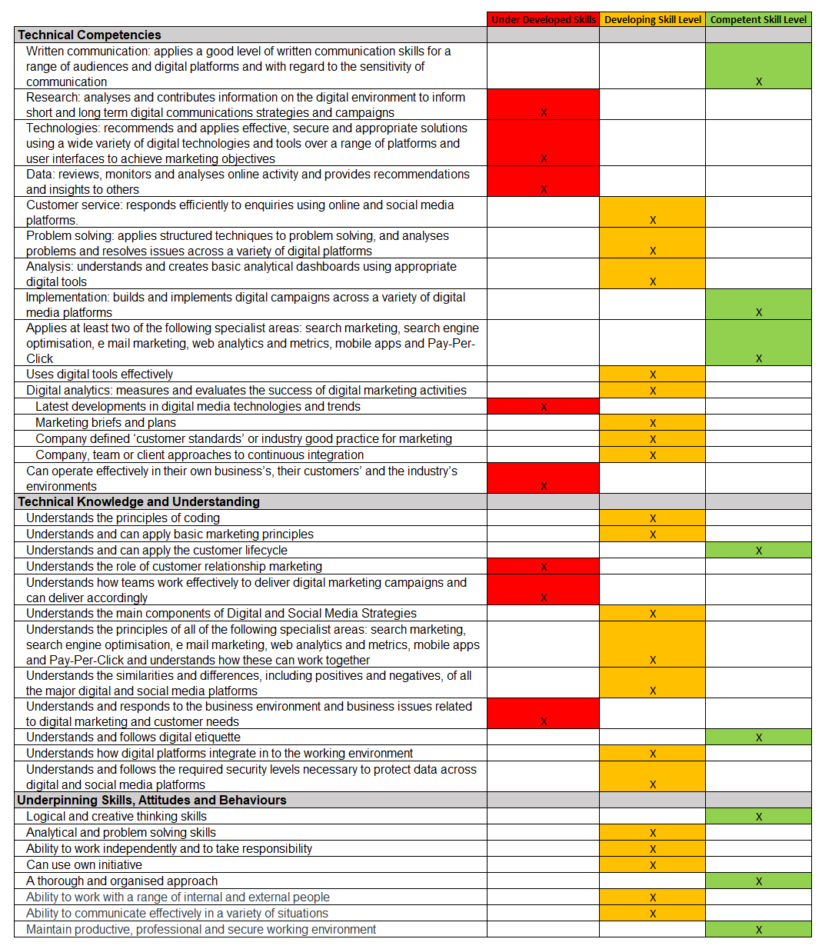

On Behalf of the Training Provider

Print Name, Job Title and Date: Training Manager 05/08/202