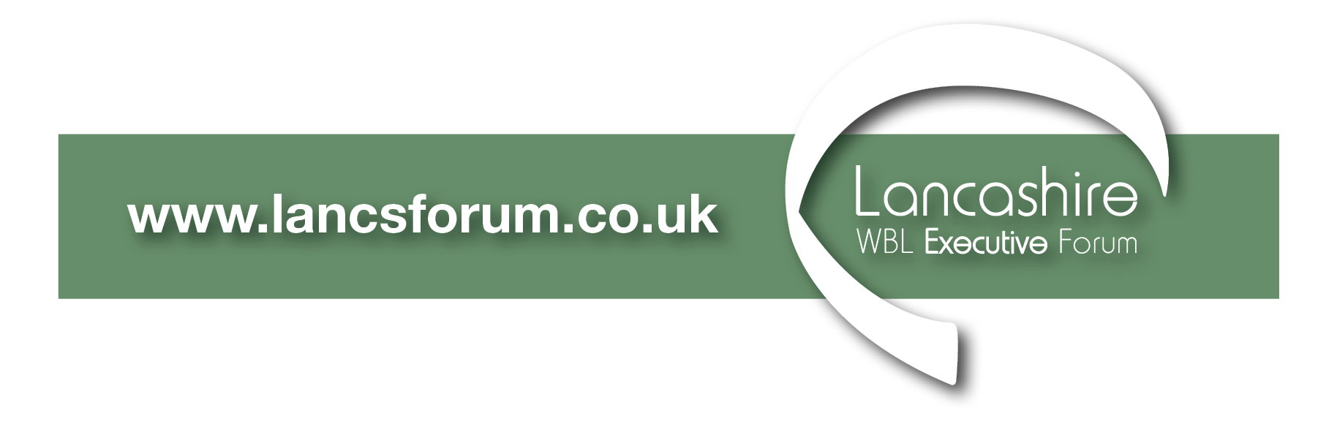
Lancashire WBL Executive Forum

Employer & Skills Sub Group

Terms of Reference

Key Purpose: To work in collaboration and partnership to maximise employer participation and develop skills provision for individual organisations and the Lancashire area

Objectives:
- To maximise opportunities in line with Government funding and initiatives i.e. 24+ Advanced Learning loans and use of Innovation code.
- Utilise LMI provided by the Local Authorities and Funding bodies to drive up employer engagement
- To identify and help develop realistic Higher Level Apprenticeships and progression opportunities
- To forge stronger partnerships between providers to increase opportunities for the sector
- To keep updated about compliance and audit issues and funding priorities.
- To promote WorldSkills and competition activity to help providers drive innovation and quality.
- Provide timely feedback to the full Forum.

