

**Improve how you engage with employers**

· Attend and contribute to our masterclasses;

· Work with our expert coaches;

· Implement change.

**Identify what your needs are**

· Review your approach to employer engagement;

· Develop a plan to implement change;

· Create a range of business metrics to track progress.

**Measure the IMPACT**

· Demonstrate the ROI you bring to businessment;

· Evaluate the change within your business.

**How the Programme works...**

**What is the Demonstrating IMPACT Programme?**

The Demonstrating IMPACT Programme has been engineered to support learning providers. Our goal is to coach and mentor you as a learning provider to meet the needs of business and demonstrate to employers that the learning solutions you offer have real value and will give them a **Return on Investment.** It is centred on your needs and is flexible to your requirements.

**“I am a learning provider … what’s in it for me?”**

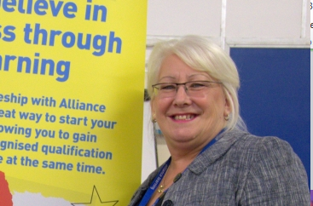

**Coaching**

These masterclasses are supplemented by one-to-one coaching. This is the exciting bit. We allocate to you a lead coach who will support your organisation to make the necessary changes. And there’s more… …if you need any specialist help and support then we will no doubt be able to source this from our wider bank of specialists!

**But don’t just take our word for it….**

“…Just a quick email to say thank you for encouraging us to join the Demonstrating IMPACT Programme.

It is proving to be a great success for myself and my managers. Our coach is fantastic and is supporting us in the changes with employer engagement and a strategic approach to growth.

Hopefully we will complete the Programme with many success stories behind us!”

**Julie Robinson, Chief Executive, Alliance Learning Ltd.**

**Sharing Ideas**

A significant aspect of our work relies upon sharing best practice and through the Demonstrating IMPACT Programme you will be able to meet likeminded individuals, swap stories and use the strength of a wider network.

**Masterclasses**

We have a range of masterclasses that will show you ‘what outstanding looks like’. We have developed these by talking to learning providers. They outline in clear, simple detail what a learning provider needs to do to engage with employers and show value. These masterclasses are ideal for senior managers looking to implement change.